Software Requirements Specification
Version 1.0

Car Park

Fresher Academy
2018

Table of Contents
Table of Contents 2
1. INTRODUCTION 3
1.1. Purpose 3
1.2. In scope 3
2. OVERVIEW 3
2.1. Actors 3
2.2. System Use Case Diagram 4
2.2.1. Human resource management staff 4
2.2.2. Car park administration staff 5
2.2.2.1. Registered car management 5
2.2.2.2. Booking office management 6
2.2.2.3. Car park management 6
2.2.2.4. Car trip management 6
3. Functional Description 8
3.1 Functional Requirements 8
3.1.1. Employee management 8
3.1.2. Booking office management 13
3.1.3. Car park management 16
3.1.4. Car management 20
3.1.5. Car trip management 24
3.1.6. Ticket management 28
3.2 Detailed Non-Functional Requirements 32
3.2.1 Logical Structure of the Data 32
3.2.2 Security 33
3.2.3 Performance 33

- INTRODUCTION
  - Purpose
The purpose of this document describes in detail the functions of "Car Park Management System". It shows the function and builds a complete system. It clearly explains the requirement of the system, gives an overview of screens and interacts with other systems or applications. And this document is for presentation with the customer to improve.
  - In scope
- The web-based system of car park management makes managing information fast, convenient and inexpensive, which provides top management services and solutions on the Internet. The car park management system is designed to meet the needs of employee management and operation administration at car park, as well as services for individuals business organizations in need.
- Main user:
- Human resource management (HRM) staff.
- Car park management staff.
The website allows to manage car park employees, operation administration, parking registration, booking office, check in/ check out of cars, car trip and parking lot.

- OVERVIEW
  - Actors
The diagram below describes all actors participating in "Car Park Management". Each actor has a different role in the system. Currently, there are the following actors: Human Resource Management staff, Car park operation administration staff.
Actor | Description
Human Resource Management staff | The staff has right to search, add, delete, edit employee information, statistic report
Car park operation administration staff | The staff has right to:  - Manage parking registration, including searching, adding, deleting, editing, and reporting statistics.  - Manage booking office, including searching, adding, deleting, editing ticket information and reporting statistics.  - Manage car park, including adding, deleting, editing car park information.

  - System Use Case Diagram
The diagram below provides an overview of the groups of functions and actors involved in building the Da Nang car park management website:
    - Human resource management (HRM) staff

Delete employee
View employee list
Add employee
Edit employee
HRM Staff

Delete employee

    - Car park operation administration staff

Car park operation administration staff

Car management
Booking office management
Parking lot management

Ticket management

Trip management

- Functional Description

Functional Requirements
    - Employee management
Use Case Name | Employee management
Use Case ID | UC02.
High Level Requirement Ref | Allows to manage information of employee such as creating, viewing details, displaying employee list
Actor | Admin.
Description | All of employee information is accessed from database and displayed on screen. The user can create, view details, display employee list.
Trigger | NA.
Pre-condition | User clicks Employee management on Menu
Post-processing

      - Add employee
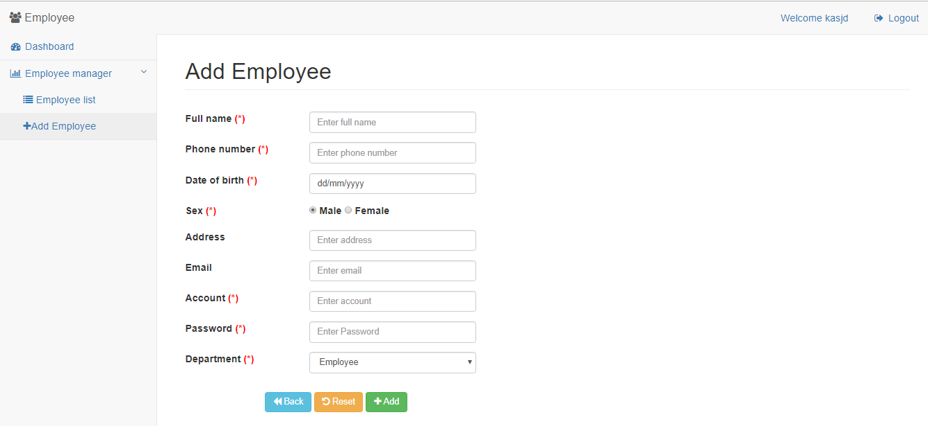
Screen of adding employee

Screen |  | Add employee
Description |  |  | Allows users to add employee
Screen Access |  |  | Amin clicks Employee management -> Employee List -> Add employee
Screen Content
Item |  |  | Type | Data |  | Description
Full name |  |  | Text field – String (50)
Date of birth |  |  | Date Picker
Sex |  |  | RadioButton
Address |  |  | Text field – String (50)
Phone number |  |  | Text field – String (50)
Email |  |  | Text field – String (50)
Account |  |  | Text field – String (50)
Password |  |  | Password – String(100)
Department |  |  | ComboBox
Back |  |  | Button |  |  | The user clicks Back to return to the previous page
Reset |  |  | Button |  |  | The user clicks Reset to delete all inputted data.
Add |  |  | Button |  |  | The user clicks Add to add employee into Database
Screen Actions
Action Name | Description |  |  |  | Success |  | Failure
Back | If user clicks Back, then system forwards to the previous screen. |  |  |  | Display the previous screen. |  | When database connection has error -> Display message “Database connection error”
Reset | If user clicks Reset, then system deletes inputted information. |  |  |  | Delete all inputted information |  | When database connection has error -> Display message “Database connection error”
Add | When the user clicks Add, the system validates data. If data is valid, then save inputted data on the database, otherwise display error message. |  |  |  | Back to screen of Employee list and display the message "Add employee successfully". |  | When inputting password with wrong format -> Display the message "Password must include uppercase, lowercase and number."
Validation | The password must have at least 6 characters, including uppercase, lowercase and number.

      - Display employee list
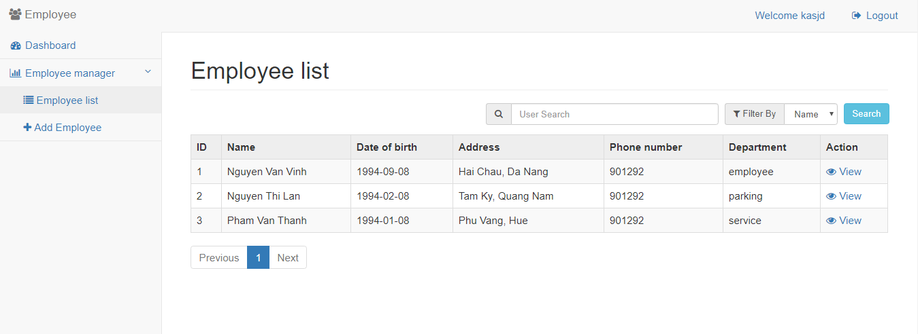
Screen of employee list
Screen |  | Employee list
Description |  |  | Display employee list
Screen Access |  |  | Admin clicks Employee management -> Employee list ->List
Screen Content
Item |  |  | Type | Data |  | Description
Search |  |  | Search Box
Search criteria |  |  | ComboBox
Search |  |  | Button
ID |  |  | Label - Integer
Name |  |  | Link - String (50) |  |  | Display name of employee. When the user clicks employee name, then forward to information page of this employee
Date of birth |  |  | Label - Date
Address |  |  | Label -String(50)
Phone number |  |  | Label - String(50)
Department |  |  | Label - String(50)
Prev |  |  | Link |  |  | When user clicks this link, then display employee list at the previous page
1 |  |  | Link |  |  | When the user clicks this link, then display employee list at page 1
2 |  |  | Link |  |  | When the user clicks this link, then display employee list at page 2
3 |  |  | Link |  |  | When the user clicks this link, then display employee list at page 3
Next |  |  | Link |  |  | When user clicks this link, then display employee list at the next page
Screen Actions
Action Name | Description |  |  |  | Success |  | Failure
Search | When user clicks Search, the system will search employee according to inputted information. |  |  |  | If the user does not input any data to search, the system will display all employees on employee list table.  Otherwise, display search result on the employee list table. |  | When database connection has error -> Display message “Database connection error”  When the system does not find out any employee, then display message “No matches”  .

    - Booking office management
      - Booking office list
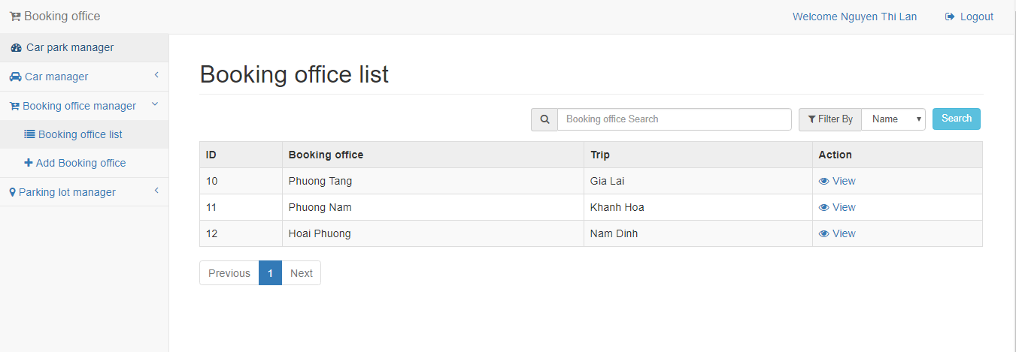
Screen of booking office list
Screen |  | Booking office list
Description |  |  | Display booking office list
Screen Access |  |  | Admin clicks Booking office -> List
Screen Content
Item |  |  | Type | Data |  | Description
Search |  |  | Search Box |  |  | The box to input search data
Search criteria |  |  | ComboBox |  |  | The box to select search criteria
Search |  |  | Button
Booking office |  |  | Link - String (50)
Trip |  |  | Label -String(50)
 |  |  | Label – String(20)
Prev |  |  | Link |  |  | When user clicks this link, then display booking office list at the previous page
1 |  |  | Link |  |  | When the user clicks this link, then display booking office list at page 1
2 |  |  | Link |  |  | When the user clicks this link, then display booking office list at page 2
3 |  |  | Link |  |  | When the user clicks this link, then display booking office list at page 3
Next |  |  | Link |  |  | When user clicks this link, then display booking office list at the next page
Screen Actions
Action Name | Description |  |  |  | Success |  | Failure
Search | When the user clicks Search, the system will search booking office according to inputted data at Search box. |  |  |  | If the user does not input any data at Search box, the system will display all booking office on list table.  Otherwise, display search result on the booking office list table. |  | When database connection has error -> Display message “Database connection error”  When the system does not find out any booking office, then display message “No matches”

      - Add booking office
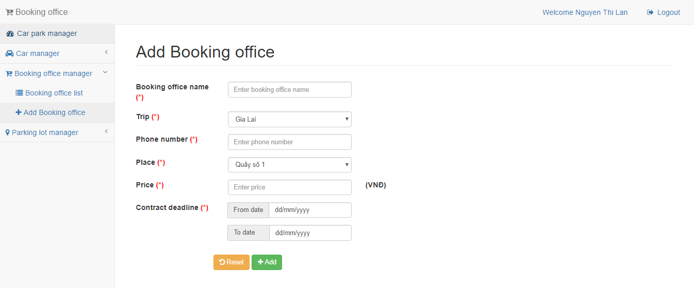
Screen of adding booking office

Screen |  | Add booking office
Description |  |  | Allows staff to add booking office information
Screen Access |  |  | Click Booking office management -> Click “Booking office” -> Click “Add”
Screen Content
Item |  |  | Type | Data |  |  | Description
Booking office name |  |  | Text field – String (50)
Phone number |  |  | Text field – String (50)
Price |  |  | Text field – String (50)
Place |  |  | ComboBox
Contract deadline |  |  | Date Picker
Reset |  |  | Button |  |  |  | The user clicks Reset to delete all inputted data
Add |  |  | Button |  |  |  | The user clicks Add to add booking office information and update database.
Screen Actions
Action Name | Description |  |  |  | Success | Failure
Reset | When user click Reset, the system will delete all inputted data |  |  |  | Delete all inputted data
Add | When the user clicks Add, the system will validate data. If data is valid, the system will update data into database, otherwise display error message. |  |  |  | Back to Detail screen and display message “Add booking office successfully” | When inputting amount of money into price box with wrong format -> Display the message "Wrong format of price."  When inputting invalid contract deadline, then the system display message “Invalid contract deadline”

    - Parking lot management
      - Parking lot list
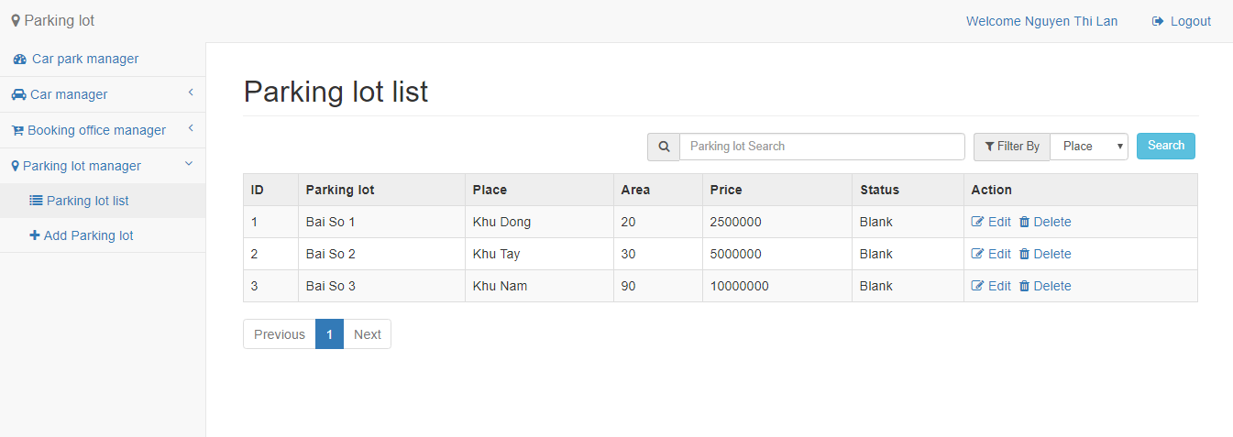
Screen of Parking lot list page

Screen |  | Parking lot list
Description |  |  | Display parking lot list
Screen Access |  |  | Admin clicks Parking lot -> List
Screen Content
Item |  |  | Type | Data |  | Description
Search |  |  | Search Box
Search criteria |  |  | ComboBox
Search |  |  | Button
ID |  |  | Label-Interger
Parking lot |  |  | Link - String (50)
Place |  |  | Label -String(50)
Area |  |  | Label -String(20)
Status |  |  | Label -String(20)
 |  |  | Label – String(20)
Prev |  |  | Link |  |  | When user clicks this link, then display parking lot list at the previous page
1 |  |  | Link |  |  | When the user clicks this link, then display parking lot list at page 1
2 |  |  | Link |  |  | When the user clicks this link, then display parking lot list at page 2
3 |  |  | Link |  |  | When the user clicks this link, then display parking lot list at page 3
Next |  |  | Link |  |  | When user clicks this link, then display parking lot list at the next page
Screen Actions
Action Name | Description |  |  |  | Success |  | Failure
Search | When the user clicks Search, the system will search parking lot according to inputted data at search box. |  |  |  | If the user does not input any data at Search box, the system will automatically display all parking lot on ticket list table. Otherwise, display the search result on ticket list table. |  | When database connection has error -> Display message “Database connection error”  When the system does not find out any parking lot, then display message “No matches”

      - Add parking lot
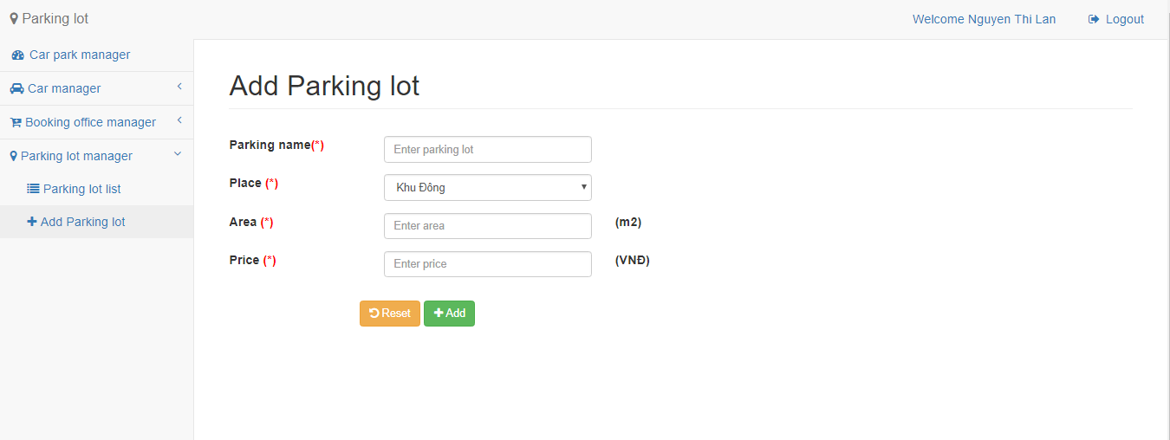
Screen of adding parking lot

Screen |  | Add parking lot
Description |  |  | Allow staff to add parking lot information
Screen Access |  |  | Click Parking lot management -> Click “Parking lot” -> Click “Add”
Screen Content
Item |  |  | Type | Data |  |  | Description
Parking lot |  |  | Text field – String (50)
Place |  |  | ComboBox
Area |  |  | Text field – String (50)
Price |  |  | Text field – String (10)
Reset |  |  | Button |  |  |  | The user clicks Reset to reset all data into default
Add |  |  | Button |  |  |  | The user clicks Add to add information of parking lot and update into database
Screen Actions
Action Name | Description |  |  |  | Success | Failure
Reset | When user click Reset, the system will delete all inputted data |  |  |  | Delete all inputted data
Add | When the user clicks Add, the system will validate data. If data is valid, the system will update data into database, otherwise display error message. |  |  |  | Back to Detail screen and display message “Add booking office successfully” | When inputted “Area” is not number, the system will display message “Please input area with number format”  When inputted “Price” is not number, the system will display message “Please input price with number format”

    - Car management
      - Car list
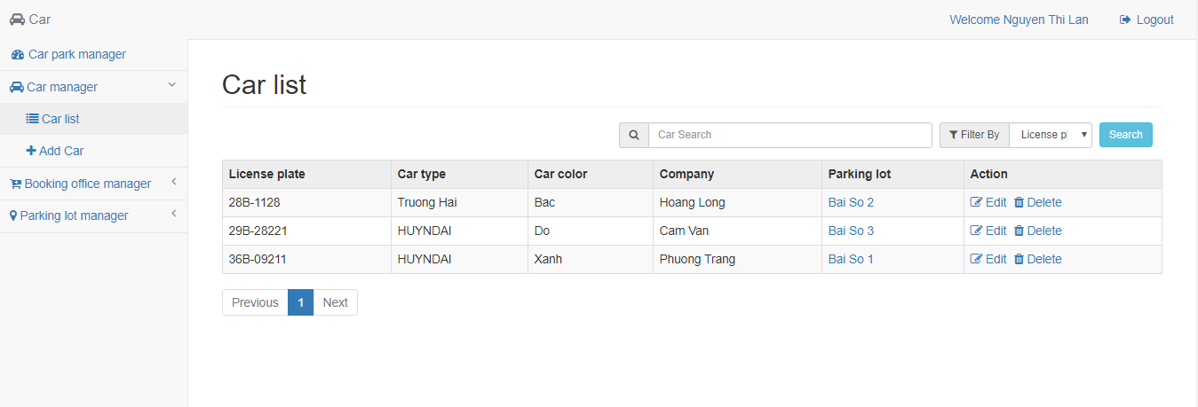
Screen of car list
Screen |  | Car list
Description |  |  | Display Car list
Screen Access |  |  | Admin clicks Car Management -> Car parking in lot -> List
Screen Content
Item |  |  | Type | Data |  | Description
Search |  |  | Search Box
Search criteria |  |  | ComboBox
Search |  |  | Button
License plate |  |  | Label - String (20)
Car type |  |  | Label -String(50)
Car color |  |  | Label -String(20)
Company |  |  | Label -String(50)
Parking lot |  |  | Label -String(50)
 |  |  | Label – String(20)
Prev |  |  | Link |  |  | When user clicks this link, then display car list at the previous page
1 |  |  | Link |  |  | When the user clicks this link, then display car list at page 1
2 |  |  | Link |  |  | When the user clicks this link, then display car list at page 2
3 |  |  | Link |  |  | When the user clicks this link, then display car list at page 3
Next |  |  | Link |  |  | When user clicks this link, then display car list at the next page
Screen Actions
Action Name | Description |  |  |  | Success |  | Failure
Search | When the user clicks Search, the system will search car according to inputted data at search box. |  |  |  | If the user does not input any data at Search box, the system will automatically display all car on ticket list table. Otherwise, display the search result on car list table. |  | When database connection has error -> Display message “Database connection error”  When the system does not find out any car, then display message “No matches”

      - Add car
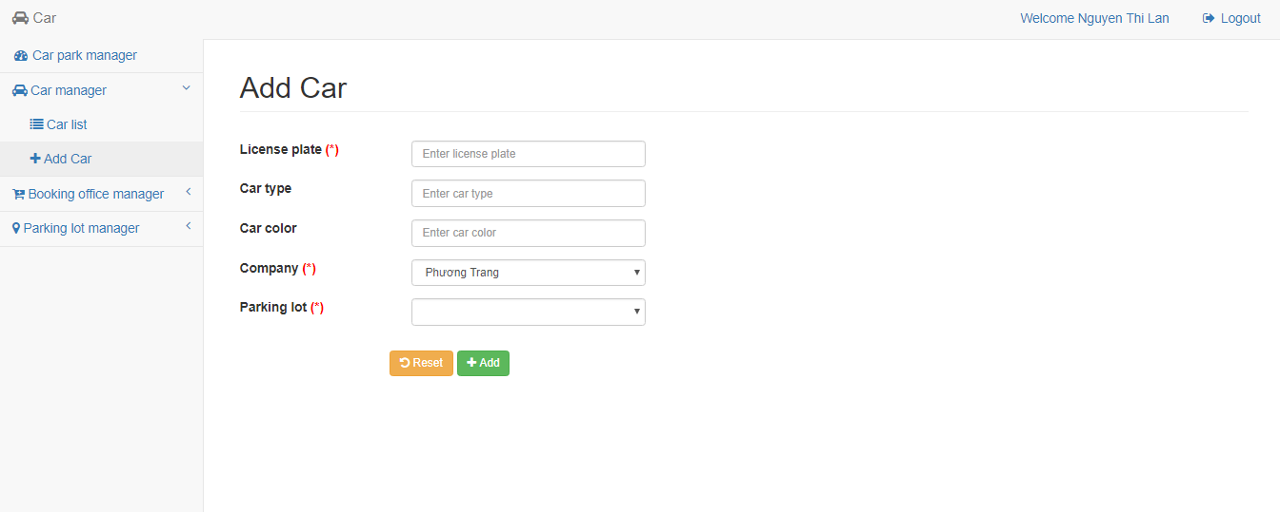
Screen |  | Add car
Description |  |  | Allow Staff to add car information
Screen Access |  |  | Click Car management -> click “Car parking in lot” -> Click “Add”
Screen Content
Item |  |  | Type | Data |  |  | Description
License plate |  |  | Text field – String (50)
Car type |  |  | Text field – String (50)
Car color |  |  | Text field – String (50)
Company |  |  | ComboBox
Parking lot |  |  | ComboBox |  |  |  | Box to select parking lot (Only display parking lots with status “Emply”
Reset |  |  | Button |  |  |  | The user clicks Reset to reset all data into default
Add |  |  | Button |  |  |  | The user clicks Add to add information of cars and update into database,
Screen Actions
Action Name | Description |  |  |  | Success | Failure
Reset | If user clicks Reset, then system deletes inputted information. |  |  |  | Delete all inputted information.
Add | When the user clicks Add, the system will validate data. If data is valid, the system will update new data into database, otherwise display error message. |  |  |  | Back to detail screen and display message “Add car successfully” | When License plate box is empty -> The system will display message ‘’Please input License plate »
    - Trip management
      - Trip list
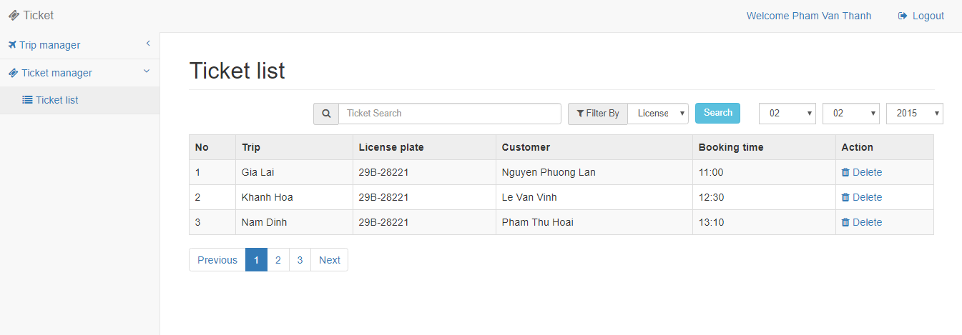
Screen |  | Trip list of company
Description |  |  | Display trip list of company
Screen Access |  |  | Admin clicks Trip management -> List
Screen Content
Item |  |  | Type | Data |  | Description
Search |  |  | Search Box
Search |  |  | Button
No. |  |  | Label - String (20)
Destination |  |  | Label -String(50)
Departure time |  |  | Label -String(20)
Driver |  |  | Label -String(50)
Car type |  |  | Label -String(50)
Booked ticket number |  |  | Label – String(20)
Prev |  |  | Link |  |  | When user clicks this link, then display trip list at the previous page
1 |  |  | Link |  |  | When the user clicks this link, then display trip list at page 1
2 |  |  | Link |  |  | When the user clicks this link, then display trip list at page 2
3 |  |  | Link |  |  | When the user clicks this link, then display trip list at page 3
Next |  |  | Link |  |  | When user clicks this link, then display trip list at the next page
Screen Actions
Action Name | Description |  |  |  | Success |  | Failure
Paging | When the user clicks any page at Paging, the system will query trip list at that page. Then the system will display trip list of the clicked page. |  |  |  | Display screen “Trip list”

      - Add trip
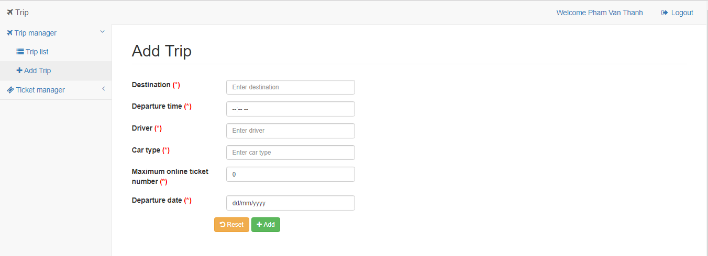
Screen |  | Add information of trip
Description |  | Allows company to add trip information
Screen Access |  | Click Trip management -> Click “Add”
Screen Content
Item |  | Type | Data |  |  | Description
Destination |  | Text field – String (50)
Departure time |  | Text field – String (50)
Driver |  | Text field – String (50)
Car type |  | Text field – String (50)
Maximum online ticket number |  | Text field – String (50)
Departure date |  | Date Picker
Reset |  | Button |  |  |  | The user clicks Reset to reset data into default
Add |  | Button |  |  |  | The user clicks Add to add information of trip into database
Screen Actions
Action Name | Description |  |  | Success | Failure
Add | When the user clicks Add, the system will validate data. If data is valid, the system will save new data into database, otherwise display error message. |  |  | Back to detail screen and display message “Add trip successfully” | When Maximum online ticket number is empty -> The system will display message ‘’Please select online ticket number’’  When inputting data over minimum, maximum of online ticket number -> The system will display message “Please input data between min and max”  When database connection has error -> Display message “Database connection error”

    - Ticket management
      - Ticket list

Screen |  | Ticket list
Description |  |  | Display Ticket list
Screen Access |  |  | The admin clicks Ticket management -> List -> List
Screen Content
Item |  |  | Type | Data |  | Description
Search |  |  | Search Box |  |  | Box to input search data
Search criteria |  |  | ComboBox |  |  | Box to select search criteria
Search |  |  | Button
No. |  |  | Label - Integer
Trip |  |  | Label - String (50)
License plate |  |  | Label - String (50)
Customer |  |  | Label -String(50)
Booking time |  |  | Label - Time
View |  |  | Link |  |  | When the user clicks View at any row, then display detail information page of ticket at that row
Prev |  |  | Link |  |  | When user clicks this link, then display ticket list at the previous page
1 |  |  | Link |  |  | When the user clicks this link, then display ticket list at page 1
2 |  |  | Link |  |  | When the user clicks this link, then display ticket list at page 2
3 |  |  | Link |  |  | When the user clicks this link, then display ticket list at page 3
Next |  |  | Link |  |  | When user clicks this link, then display ticket list at the next page
Screen Actions
Action Name | Description |  |  |  | Success |  | Failure
Search | When the user clicks Search, the system will search ticket according to inputted data at search box. |  |  |  | If the user does not input any data at Search box, the system will automatically display all tickets on ticket list table. Otherwise, display the search result on ticket list table. |  | When database connection has error -> Display message “Database connection error”  When the system does not find out any ticket, then display message “No matches”
View | When the user clicks View at any row, the system will query information of the ticket at that row. Then the system will forward to screen View detail of ticket. |  |  |  | Display screen “View detail of ticket.” |  | When database connection has error -> Display message “Database connection error”
Paging | When the user clicks any page at Paging, the system will query 10 records of tickets at that page. Then the system will display ticket list of the clicked page. |  |  |  | Display screen “Ticket management”

      - Delete ticket
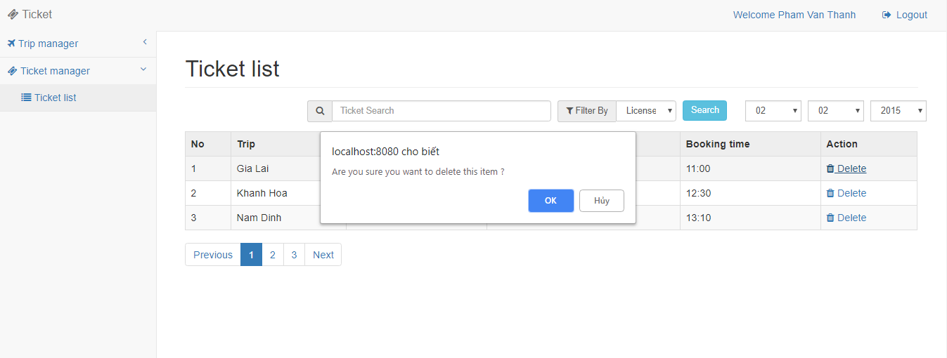
Screen | Delete ticket
Description |  | Allows company to delete ticket
Screen Access |  | Click Ticket management -> Click “List” -> Click “Delete”
Screen Content
Item |  | Type | Data |  | Description
Title |  | Label-String (20) |  |  | Display title of popup
Content |  | Label – String (50) |  |  | Display content of popup, warning users to confirm before deleting.
Yes |  | Button |  |  | Click Yes if deleting ticket
No |  | Button |  |  | Click No if not deleting ticket
Screen Actions
Action Name |  | Description |  | Success |  | Failure
No |  | If the user does not want to delete the ticket, then click No |  | Close Popup, display the current page. |  | When database connection has error -> Display message “Database connection error”  The screen still displays the current page
Yes |  | If the user confirms to delete the ticket, then click Yes |  | The screen displays message “Delete successfully” and back to Ticket list screen. |  | When database connection has error -> Display message “Database connection error”  The screen still displays the current page

Detailed Non-Functional Requirements
    - Logical Structure of the Data
The logical structure of the data to be stored on the system is given below:
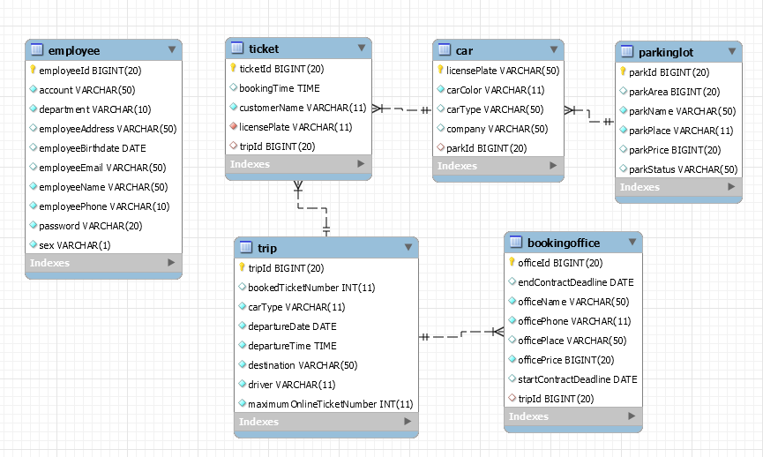

    - Security
TBD
    - Performance
TBD
    - Technial Requirement
Framwork : Spring framwork version 4.x
IDE, tools : Eclipse, Maven 3.x
Server tool : Tomcat 8.x
Java version : Java 1.8 or late
Data base : Oracle 11g

